Program 6:
Working with Gradle: Setting Up a Gradle Project, Understanding Build Scripts (Groovy and Kotlin DSL), Dependency Management and Task Automation
Step 1: create directory using command mkdir MyGradleApp and enter the directory using the command cd MyGradleApp

Step 2: Type the command gradle init –type java-application
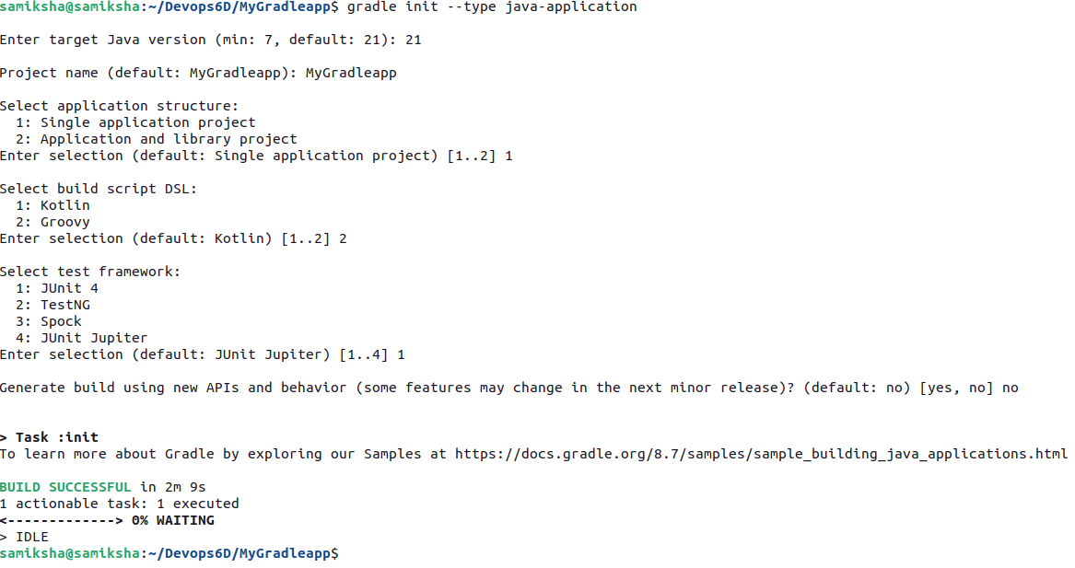
Step 3: Go to app directory to find build.gradle. Open build.gradle and type the code in build.gradle
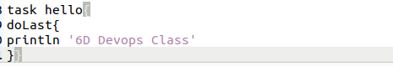
Step 4: type the command gradle build to compile the source code and package the app.
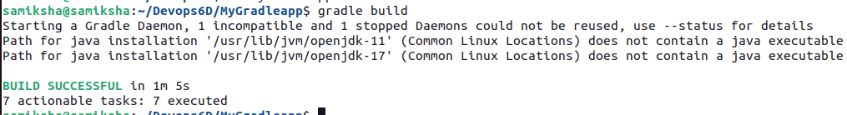
Step 5: type the command gradle run to execute the default Hello World application
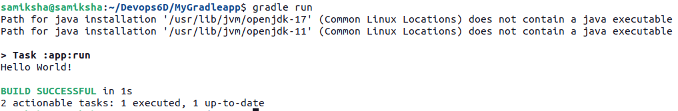
Step 6: type the command gradle <task-name> to run the task
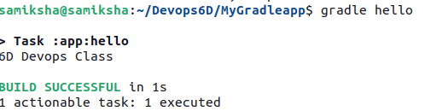

Program 7:
Practical Exercise: Build and Run a Java Application with Maven, Migrate the Same Application to Gradle
Step 1: To build a basic Java Application with Maven Project, run following command:
mvn archetype: generate -DgroupId=com.example -DartifactId=MyMaventoGradle
-DarchetypeArtifactId=maven-archetype-quickstart -DinteractiveMode=false
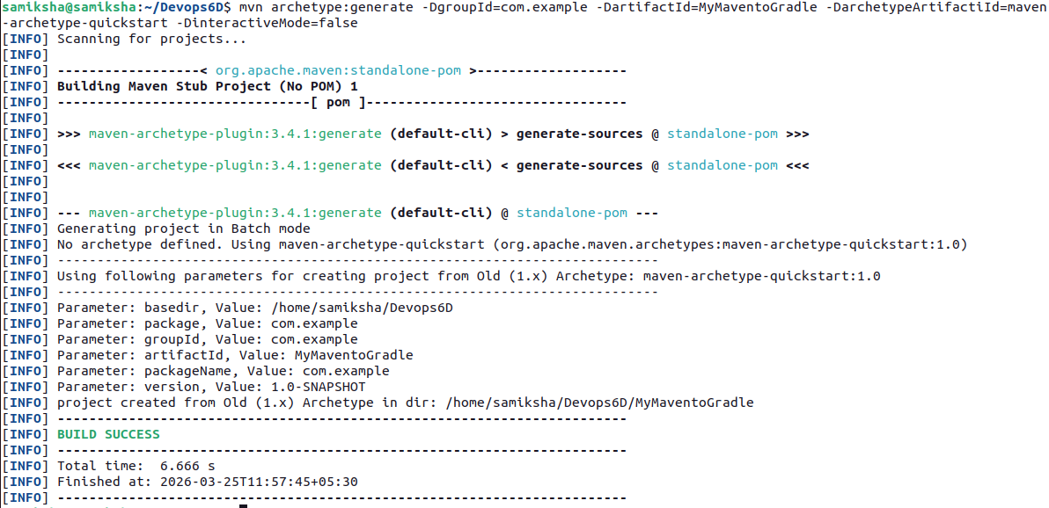
Step 2: enter the MyMaventoGradle directory and open the pom.xml file.
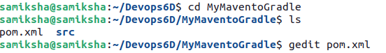
Add the code in the pom.xml
<project xmlns="http://maven.apache.org/POM/4.0.0" xmlns:xsi="http://www.w3.org/2001/XMLSchema-instance"
xsi:schemaLocation="http://maven.apache.org/POM/4.0.0 http://maven.apache.org/maven-v4_0_0.xsd">
<modelVersion>4.0.0</modelVersion>
<groupId>com.example</groupId>
<artifactId>MyMavenApp</artifactId>
<packaging>jar</packaging>
<version>1.0-SNAPSHOT</version>
<name>MyMavenApp</name>
<url>http://maven.apache.org</url>

<!-- Properties: Customize Java version or plugin versions -->
<properties>
<maven.compiler.source>11</maven.compiler.source>
<maven.compiler.target>11</maven.compiler.target>
</properties>
<dependencies>
<dependency>
<groupId>junit</groupId>
<artifactId>junit</artifactId>
<version>3.8.1</version>
<scope>test</scope>
</dependency>
</dependencies>
<!-- Build: Configuring plugins and build settings -->
<build>
<plugins>
<!-- Example: Maven Compiler Plugin to compile Java code -->
<plugin>
<groupId>org.apache.maven.plugins</groupId>
<artifactId>maven-compiler-plugin</artifactId>
<version>3.8.1</version>
<configuration>
<source>1.7</source>
<target>1.7</target>
</configuration>
</plugin>
<!-- Example: Maven Surefire Plugin to run tests -->
<plugin>
<groupId>org.apache.maven.plugins</groupId>
<artifactId>maven-surefire-plugin</artifactId>
<version>2.22.2</version>
</plugin>
<plugin>
<groupId>org.apache.maven.plugins</groupId>
<artifactId>maven-jar-plugin</artifactId>
<version>3.1.0</version>
<configuration>
<archive>
<manifestEntries>
<Main-Class>com.example.MainClass</Main-Class>
</manifestEntries>
</archive>
</configuration>
</plugin>
</plugins>
</build>
</project>
Step 3 : Run mvn clean install to compile your project
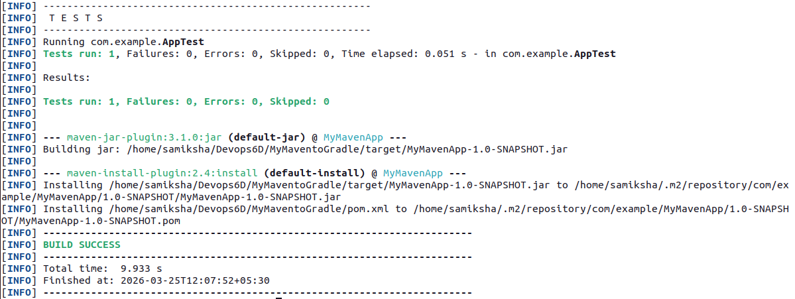

Step 4: Type the command mvn exec:java –Dexec.mainClass=”com.exampls.App” to execute
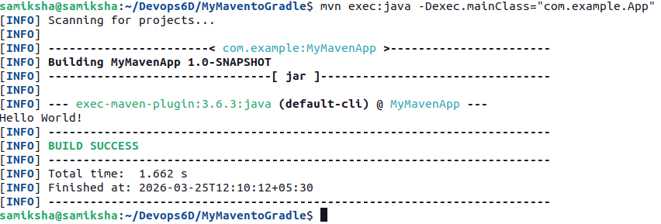
Step 5: Type the comman gradle init --type pom to initialize a Gradle Project using gradle init command with type as pom, command converts pom.xml structure to Gradle’s build.gradle.
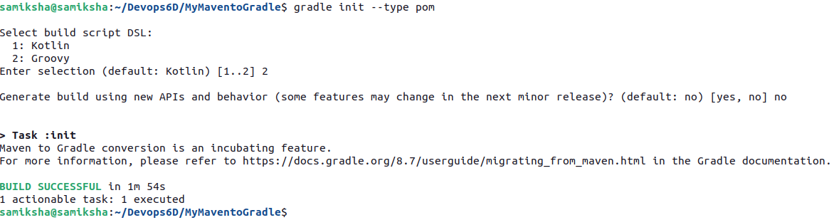
Type the ls command to see all the files and directories.

